APP DEV AND EMERGING TECHs

Jericho Bruce Rivero | BSIT

Activity 3

1. Write a C Language system that will display the average grade of the below data.  
   Display also the given data.

Grades:

95, 87, 90, 85, and 80.

Put your source code and screenshot of the running program below.

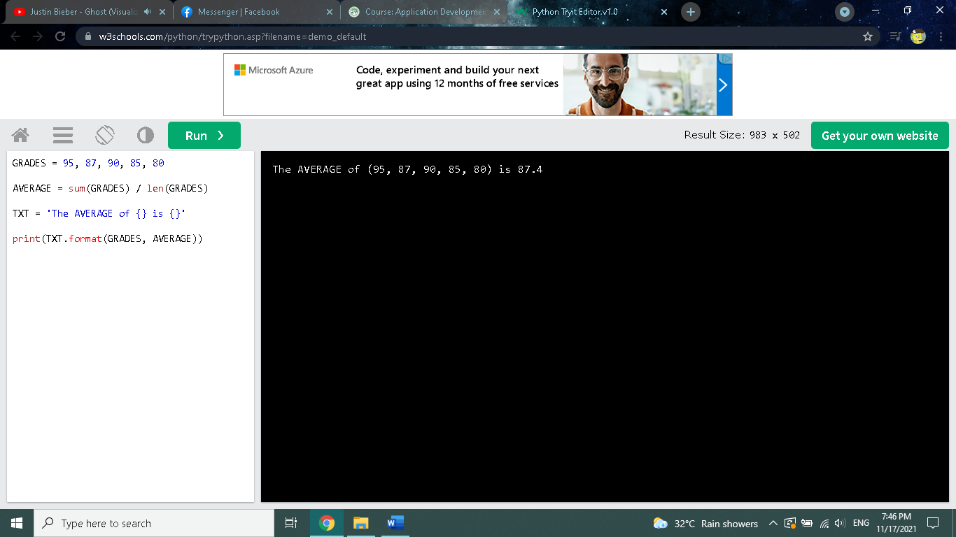

GRADES = 95, 87, 90, 85, 80

AVERAGE = sum(GRADES) / len(GRADES)

TXT = 'The AVERAGE of {} is {}'

print(TXT.format(GRADES, AVERAGE))